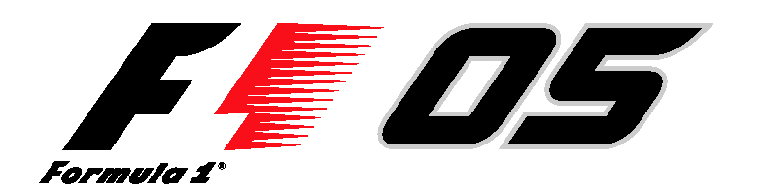

FORMULA ONE™ on PlayStation is GO GO GO
The Real Deal… the only official FORMULA ONE™ game
Race first … the new Istanbul race circuit
PlayStation®2… version launched

The FORMULA ONE 2005 season received a boost today with the release of the official game of FORMULA ONE from Sony Computer Entertainment Europe - FORMULA ONE 05™.

The game not only captures the ‘real’ essence of the sport but delivers an unrivalled experience with real racing satisfaction. FORMULA ONE 05 boast all the official cars, drivers and teams, including new arrival Istanbul track which means you can race the track before the flag goes down on August 21st.

Fans will be able to explore new functions and game play modes with pit stop, a new career mode and the opportunity to race in the cars that have made FORMULA ONE history.

At Home with FORMULA ONE 05 on PlayStation 2

- New Driver Aids means the game takes seconds to learn but hours to master. Novice gamers and FORMULA ONE fans alike will also appreciate new driver aids with optional functions including automatic breaking, spin recovery and steer assistance to keep you on track..

- New Skills: Get in tune with four new learner aids: Loading Screen Tips give you the circuit map with racing tips; a Helper Ticker scrolls across the screen explaining each option quickly; Audio Information Tips provide expert guidance in the garage and pits and Pit Crew Reminders can be requested to deliver advice on tricky corners or correcting errors.

- Old & New: FORMULA ONE 05 lets you re-live the classic cars and the classic races as you unlock historic cars and new bonus tracks so you can make your own history.

- New Facts: Become a racing expert with the new information centre that includes driving tips for each track and a comprehensive glossary of FORMULA ONE terms.

- New Career: Challenge yourself with the improved career mode option offering more depth than ever before for wannabe racers, increasing the longevity of the game play with a greater variety of tests and opportunities. More/…

Page 2 of 2

- New Competition: Go online for the ultimate head-to-head racing experience where you can battle against players from all over the world; prove yourself in the world ranking ladders where your best lap time and average speeds across circuits are judged against other drivers or join a ‘buddy’ list so can regularly take on head to head a group of players to come the ultimate champion.

- New stuff: Manage your own ‘pit-stop’ and enjoy the new pre-race grid line-up with mechanics, grid girls, journalists & cameramen.

Ends

Notes to Editors

For further information please contact your local PR Manager.

About Sony Computer Entertainment Europe Ltd.
Sony Computer Entertainment Europe (SCEE), based in London, is responsible for the distribution, marketing and sales of PS one®, PlayStation®2 and PlayStation Portable® software and hardware in 102 territories across Europe, the Middle East, Africa and Oceania. SCEE also develops, publishes, markets and distributes games software for the three formats, and manages the third party licensing programs for these platforms in the PAL territories. At the end of March 2005, over 40 million PlayStation® units had been shipped across these PAL territories, over 102 million worldwide. Between its European debut on 24 November 2000 and the end of March 2005, over 31 million PlayStation®2 units have been shipped across the PAL territories, over 87 million world-wide, making it one of the most successful consumer electronic products in history.

PlayStation and the PlayStation logo, PS one and PS2 are registered trademarks of Sony Computer Entertainment Inc. All other trademarks are property of their respective owners.

More information about PlayStation products can be found at http://www.scee.com and www.playstation.com.

